# Storyboards:

## Mark George:

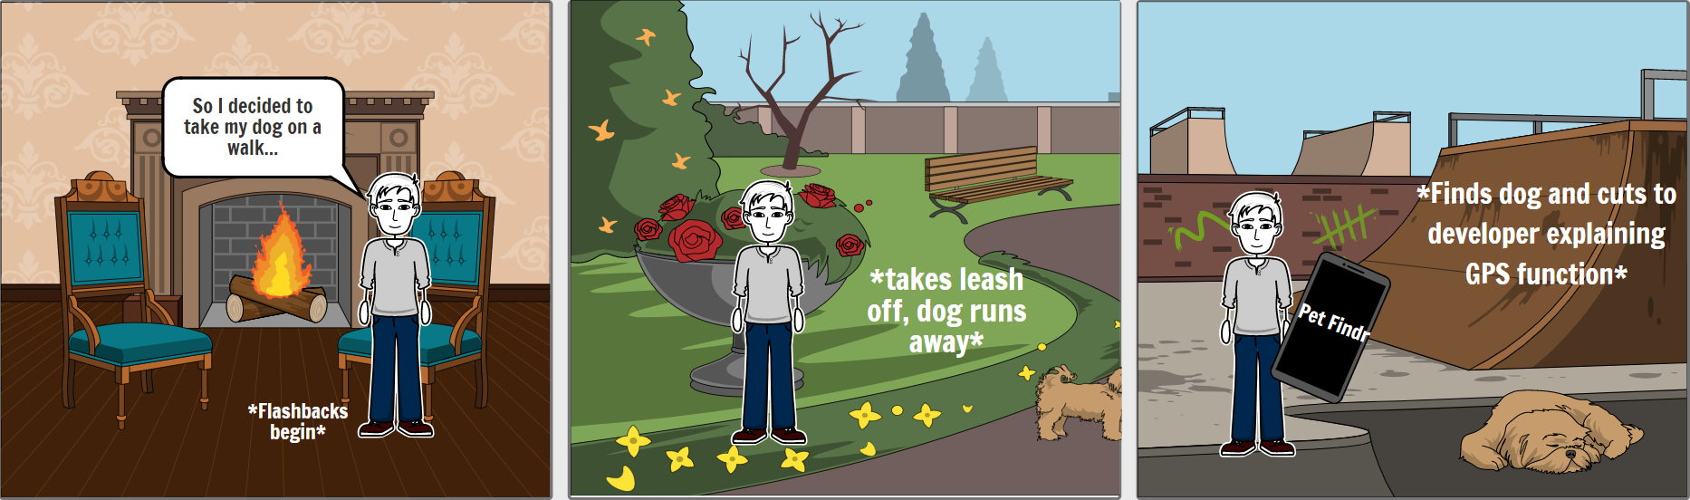

## Kanav Atri:

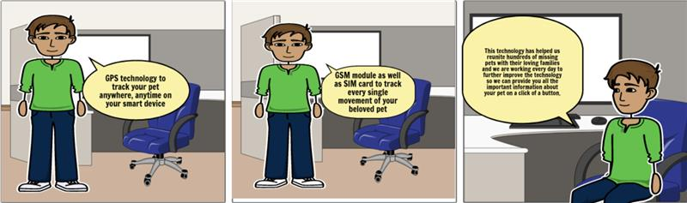

## Victor van der Meer:

## Quentin Schuster:

## Connor Abdulai:

